**Name ………………………………………………………………………………………………………..**

**Candidate’s Name:……………………………………………………………………………………**

**Centre No./Index No: ……………………………………………Signature:……………………**

273/1

Geography

Paper 1

1 ½ hours

**REOURCEFUL MOCK EXAMINATIONS, 2017**

**Uganda Certificate of Education**

Geography

**Paper 1**

2 hours

**INSTRUCTIONS TO CANDIDATES**

* *This paper consists of parts I and II.*
* *Part I and section A of part II are compulsory.*
* *Answer only one question from section B of part II.*
* *Answers to all questions must be written in the answer sheets provided.*
* *Any additional question(s) answered will not be marked.*

***PART I***

***Objective type Questions (30 MARKS)***

1. The rate at which temperature falls with increasing altitude is called

A. Temperature inversion. B. Lapse rate.

C. Atmospheric pressure. D. Solar radiation.

2. The differences in the shapes of east Africa’s volcanoes is mainly due to differences in the

A. style of eruption of lava.

B. rate of lava flow and cooling.

C. chemical composition of lava.

D. amount of lava in the central vent.

3. The Lake Victoria region of Uganda is densely populated mainly due to

A.heavy rainfall and fertile soils.

B. existence of large clay deposits.

C. well-developed railway and marine services.

D. rapid industrial development.

4. The natural vegetation in northern Kenya is characterized by

A. thorny trees and bushes.

B. dense undergrowth.

C. tall grass.

D. climbing plants.

5. Diamond in Tanzania is mined on large scale mainly because it

A. exists near the earth’s surface .

B. is the most precious mineral in Tanzania.

C. exists in large quantities.

D. exists in flat areas.

6. Which of the following fault scarps are found in Kenya?

A. Chunya and Mau.

B. Nandi and Kericho.

C. Kichwamba and Elgeyo.

D. Kilosa and Manjane.

7. The following features are associated with waterfalls in highland areas of East Africa except

A. cliffs. B. hard rock layers.

C. plungepool. D. broad flat valley.

8. Which one of the following is an inland fishing port in Tanzania?

A. Kigoma. B. Mtwara. C. Dodoma. D. Dar-es-salaam.

9. Kenya has the highest rate of urban unemployment in East Africa mainly because it has

A. the largest portion of dry land.

B. a high population growth rate

C. the highest rate of urbanization.

D. a large number of immigrants.

10. Warping in East Africa has led to the formation of

A. Albert graben. B. Victoria basin.

C. Katwe depression. D. Aberdare ranges.

11. Which of the following are non-traditional cash crops in East Africa?

A. Rice and Pineapples. B. Cotton and Rice.

C. Pineapples and Tea. D. Cotton and Tea.

12. Which one of the following is an extrusive igneous rock?

A. Granite. B. Diorite. C. Gneiss. D. Pumice.

13. The wearing away of the rocks beneath the glaciers is referred to as

A. abrasion. B. freeze and thawing.

C. plucking. D. solution.

14. Which of the following is a characteristic of laterites?

A. Rich in humus content.

B. Have few living organisms.

C. Support growth of huge trees.

D. Rich in soluble mineral nutrients.

15. The location of an oil refinery at Changamwe-Mombasa is mainly due to presence of

A. a dense transport network.

B. a large labour force.

C. accessibility to oil

D. a favourable government oil policy.

16. Which of the following is the most popular tourist activity in Uganda?

A. Hiking. B. Mountain gorilla tracking.

C. Mountain climbing. D. cultural tourism.

17. Which one of the following is the largest and busiest port along the East African coast?

A. Tanga. B. Malindi. C. Dar-es-salaam. D. Mombasa.

18. Which of the following coastal feature is of prominence on Mafia Island?

A. Barrier beach. B. Headland.

C. Atoll. D. Ria.

19. The persistence of nomadic pastoralism in East Africa is mainly due to

A. low population density.

B. low and unreliable rainfall.

C. limited government support.

D. high incidences of pests and diseases.

20. Which one of the following is the most important form of energy in East Africa?

A. Biomass. B. Hydroelectric power.

C. Geothermal power. D. petroleum.

21. The type of delta found on River Omo as it flows into Lake Turkana is known as

A. bird’s foot. B. estuarine.

C. arcuate. D. both arcuateand bird’s foot.

22. Chemical weathering involves

A. removal of weathered rock particles.

B. change in the rock’s physical composition.

C. alternate expansion and contraction ofrocks.

D. decomposition of rocks on the earth’s surface.

23. Which one of the following is the major crop grown on the Galole irrigation scheme along the lower slopes of Mt.Kenya?

A. Cotton. B. Sugar cane.

C. maize. D. Rice.

24. Which of the following rocks are most resistant to erosion?

A. Rock salt and Dolomite. B. Quartzite and Dolomite.

C. Rock salt and Gabbro. D. Quartzite and schist.

25. Which one of the following is the major factor influencing soil formation in East Africa?

A. Relief. B. Nature of the parent rock.

C. Living organisms. D. Climate.

26. Entebbe is known as a peninsular because it is

A. surrounded by water on most sides.

B. surrounded by water on all sides.

C. submerged by water.

D. a gently sloping rock surface along the lake shores.

27. A sea breeze occurs when

A. land around water bodies is heated slowly.

B. land becomes hotter than the water body.

C. the water body becomes hotter than the land.

D. cool air blows from the land towards the sea.

28. Which one of the following is the most economically valuable forest type along mountain Rwenzori and Kilimanjaro?

A. temperate forest. B. bamboo forest.

C. tropical rainforest. D. savanna woodland.

29. Lines drawn on a map joining places with the same atmospheric pressure are known as

A. isobars. B. Isotherms. C. Isohytes. D. Isorymes.

30. Tea in East Africa grows well in areas with

A. peat soils. B. acidic soils. C. chernozems. D. permafrost.

**PART II**

**MAPWORK, PHOTOGRAPH INTERPRETATION, FIELD WORK AND EAST AFRICA.**

Answer four questions from part II, including questions 1, 2 and 3 which are compulsory.

**SECTION A**

**1. COMPULSORY QUESTION : MAPWORK (20 marks)**

**Answer all parts of this question.**

**Study the 1:50,000 (UGANDA) NAMWENDWA map extract, sheet 62/2, series Y732, Edition 1 – U .S.D. and answer the questions that follow.**

a(i) state the grid reference of the borehole to the west of Namwendwa Ginnery. (1mrk)

(ii) Identify the man made feature found at grid reference 295033. (1mrk)

b) Determine the;

(i) distance covered by the section of Bugaya-Luzinga dry weather road in Kilometers. (2mrks)

(ii) bearing of the borehole to the South of Namwendwa station from the road junction to the north of Hindu crematorium. (2mrks)

(iii) Vertical interval used on the map extract. (2mrks)

c) Draw a sketch map of the area shown and on it mark and name:

(i) railway line.

(ii) Plantations.

(iii) Papyrus swamps north of northing 00.

(iv) river Lumbuye.

(v) dry weather roads south of northing 96. (7mrks)

d) Describe the:

(i) relief of the area shown on the map extract. (3mrks)

(ii) problems faced by people living in the area shown on the map extract(2mrks)

**2. PHOTOGRAPH INTERPRETATION (COMPULSORY) (15mrks)**

**Answer all parts of this question.**

Study the photograph provided below and answer the questions that follow.

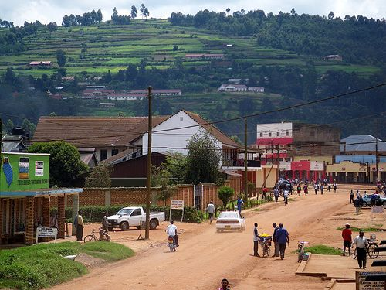

a) Draw a landscape sketch of the area shown on the photograph and on it mark and name:

(i) any two physiographic regions.

(ii) any three landuse types. (5mrks)

b) Describe the relationship between relief and land use in the area shown on the photograph. (3mrks)

c) Explain the conditions favouring any one land use identified in a(ii) above. (4mrks)

d) Giving reasons for your answer, suggest one area in East Africa where this photograph could have been taken. (2mrks)

**3. COMPULSORY FIELDWORK QUESTION (15 MARKS)**

**Answer all parts of this question.**

For any one fieldwork study you have carried out either as an individual or a group.

a(i) State the topic of study. (2mrks)

(ii) Outline the objectives of study. (2mrks)

b) Describe how you used any two of the following methods to collect data

(i) Observation.

(ii) Measurement.

(iii) Recording.

(iv) Map orientation. (6mrks)

c) What were the finds of your fieldwork study? (3mrks)

d) What challenges did you face in the field? (2mrks)

**SECTION B: EAST AFRICA (20 MARKS)**

**Answer only one question from this section.**

4. a) Draw a sketch map of East Africa and on it mark and name :

(i) Climate zones; equatorial, Savannah and semi desert.

(ii) Water bodies; Indian Ocean and Lake Victoria.

(iii) The equator. (7mrks)

b) Describe the characteristics of equatorial climate. (4mrks)

c) Explain the conditions that have led to equatorial climate in East Africa. (4mrks)

d(i) Explain the economic activities associated with equatorial climatic areas in east Africa. (3mrks)

(ii) Outline the problems facing people in equatorial climatic areas of East Africa (2mrks)

5. Study the table below showing oil product output at Kenya’s Mombasa Refinery in 2011 and answer the questions that follow.

|  |  |
| --- | --- |
| Oil product | Output (%) |
| Fuel oil | 30 |
| Light diesel (gas oil) | 23 |
| Kerosene and jet/turbo fuel | 22 |
| Motor gasoline | 10 |
| Liquefied petroleum gas | 02 |
| Other | 13 |

***Source: Kenya Petroleum Refineries Ltd***

1. Draw a percentage bar graph to show the above data. (7 mrks)
2. Identify the;
3. highest,
4. lowest

oil product output. (2mrks)

1. Explain the importance of oil refining in Mombasa. (6mrks)
2. (i) Outline the problems associated with oil refining in Mombasa. (3mrks)

(ii) What steps should be taken to solve the problems in d(i) above? (2mrks)

6. a) Distinguish between plucking and basal sapping. (4mrks)

b) Identify the three areas of glacial activity in East Africa (3mrks)

c) Describe any three glacial erosional landforms found in East Africa. (9mrks)

d) Explain the advantages of glaciation in East Africa. (4mrks)

7. Study the map of Mwea – Tebere irrigation scheme provided and answer the questions that follow.

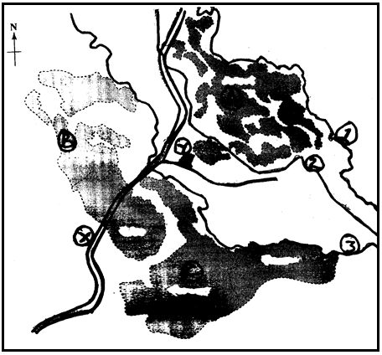

**B**

**C**

**A**

1. Name;
2. irrigated land marked A, B and C.
3. rivers marked 1, 2 and 3.
4. type of transport means marked X.
5. agricultural facility marked Y. (8mrks)
6. Describe the conditions favouring rice growing in the Mwea-Tebere irrigation scheme. (5mrks)
7. Explain the benefits of the Mwea-Tebere irrigation scheme to the people of Kenya. (4mrks)
8. Outline the problems facing the Mwea-Tebere Irrigation scheme. (3mrks)

**END**